|  |  |  |  |
| --- | --- | --- | --- |
| **paf_kiet_logo** | **COLLEGE OF COMPUTING AND INFORMATION SCIENCES** | | |
| **Final Assessment of Lab Exam (Fall 2020 Semester)** | | |
| **Class Id** | 105127 | **Course Title** | Numerical Computing |
| **Program** | BSCS | **Campus / Shift** | North/ Morning |
| **Date** | November 26, 2020 | **Total Marks** | 20 |
| **Duration** | 03 hours | **Faculty Name** | Iqra Fahad |
| **Student Id** |  | **Student Name** |  |
| **Code** | **C** |  |  |

**Instructions:**

* Fill out your Student ID and Student Name in above header.
* Do not remove or change any part question paper.
* Write down your answers with title “Answer for Question# 00”.
* Handwritten text or image should be on A4 size page with clear visibility of contents.
* In case of CHEATING, COPIED material or any unfair means would result in negative marking or ZERO.
* Viva can be taken with prior notice, where deemed necessary.
* **Caution:** Duration to perform Final Assessment is **02 hours only and 01 hour** is given to cater all kinds of odds in submission of Answer-sheet. **Therefore, if you failed to upload answer sheet on LMS (in PDF format) within 3 hours’ limit, you would be considered as ABSENT/FAILED.**

**Question 01:**

The population of Mississippi during three census periods was as follows:  
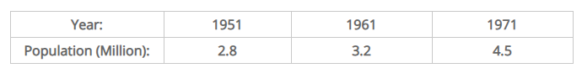

Interpolate the population during 1966 without using any built-in function of Python. Also determine the equation that satisfies the given data.

**Question 02**

A dietitian wishes to plan a meal around three foods. The percentage of the daily requirements of proteins, carbohydrates, and iron contained in each ounce of the three foods is summarized in the following table:

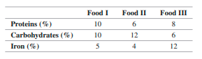

Determine (using Python code) how many ounces of each food the dietitian should include in the meal to meet exactly the daily requirement of proteins, carbohydrates, and iron (100% of each).